Location Based Intelligent Mobile Organizer
Abstract:
Pervasive existence of the mobile phones has demanded a need for developing variety of light weighted Operating Systems as well as applications that would facilitate user requirements. Of late, smart phones have grown significantly in terms of both processing and user interface which will satisfy the growing ubiquitous demands of user. We strongly perceive that limitations in existing tracking based applications will cripple the scalability of using mobile phones in any location, at any time, by anyone. Hence, demanding the need for Ubiquitous applications to be deployed in a smart phone. This paper aims at developing an integrated application namely Location Based Intelligent Mobile Organizer that will facilitate user with location aware services. Retailers could also publish their product discount information by registering into our authorized web site. All users with this loaded application will reap immense benefit through this application. This intelligent observer module is developed using Jdk 6, Eclipse and Android 4.2(Google api) installed on Windows Operating System. Being at a point of interest user will be able associate task and view the discount information as mobile alerts. This observer application is integrated into a pervasive device and can form as an integral part of our routine activities.
Overview:
Global Positioning Systems is a top priority technology used for locating a device position accurately. Methodology for tracking can be done using a GPS receiver which is an additional hardware integrated in most of mobile equipment. We have used GPS as the approach idea for location tracking. The platform used for development is Android Operating System Customer friendly user interface letting user to enter the task and store it for future retrieval is done using the exclusive SQLite inbuilt database available in Android mobile. User can align task associated with any location and retrieving details as alert before reaching a desired location of interest. User entering into this application is given an option for connecting to the database so as to verify the location updates. Information is then delivered at the right time in the right place to the right person. The mobile user will also be able to receive retail offers and discount information in the surrounding by this intelligent observer module.

Our project main features:

1 .Adding and editing task

2. Storing task in SQLite database

3. Tracking and displaying location

4. Viewing retail discount information

5. Retrieving information on mobile device
Existing System:
Pervasive existence of the mobile phones has demanded a need for developing variety of light weighted Operating Systems as well as applications that would facilitate user requirements. Of late, smart phones have grown significantly in terms of both processing and user interface which will satisfy the growing ubiquitous demands of user. We strongly perceive that limitations in existing tracking based applications

Proposed System:

Most promising type of contextual information is the proximity selection known as Location Based Service Tracking location of a mobile device accurately has been a challenging research topic for decades. Global Positioning Systems is a top priority technology used for locating a device position accurately. Methodology for tracking can be done using a GPS receiver which is an additional hardware integrated in most of mobile equipment. We have used GPS as the approach idea for location tracking. The platform used for development is Android Operating System,is been proven as the best operating system for a context-aware location based services. Customer friendly user interface letting user to enter the task and store it for future retrieval is done using the exclusive SQLite inbuilt database available in Android mobile. User can align task associated with anylocation and retrieving details as alert before reaching a desired location of interest. User entering into this application is given an option for connecting to the database so as to verify the location updates. Information is then delivered at the right time in the right place to the right person. The mobile user will also be able to receive retail offers and discount information in the surrounding by this intelligent observer module.

IMPLEMENTATION
Global Positioning Systems (GPS) is a top priority technology used for locating a device position accurately. Methodology for tracking can be done using a GPS receiver which is an additional hardware integrated in most of mobile equipment. We have used GPS as the approach idea for location tracking. The platform used for development is Android Operating System Customer friendly user interface letting user to enter the task and store it for future retrieval is done using the exclusive SQLite inbuilt database available in Android mobile. User can align task associated with any location and retrieving details as alert before reaching a desired location of interest. User entering into this application is given an option for connecting to the database so as to verify the location updates. Information is then delivered at the right time in the right place to the right person. The mobile user will also be able to receive retail offers and discount information in the surrounding by this intelligent observer module.

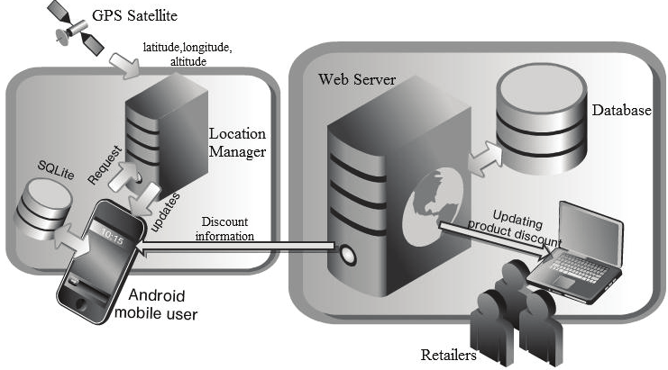
6.1 Graphical User Interface
The user interface is kept simple and understandable. The user need not take any additional effort to understand the functionality and navigation in the application. The colors are chosen in such a way that user can easily understand where the input has to be given. Hints are given to help the user in giving the correct input.
The following are the main screens and features in this application.
- Splash Screen
- Home Screen
- View Task
- Add new task
- Discount
.
MODULE DESCRIPTION:
- Adding task.
- Tracking Location.
- Task displayed as alert.
- Upload retail discount.
- Viewing retail discount information.
Adding Task:-
Task is entered and stored in the SQLite database. Location tracking is performed using the GPS service. Changes in location can be emulated with the help of (Key Hole Markup language) KML file in Android. The location change is compared with the database entries to see if there are tasks associated to the current location.

Tracking Location.
Location application will get the task input from user and will listen for location changes. The new co-ordinates are passed to service routine written for handling task.

Task displayed as alert.
User can align task associated with any location and retrieving details as alert before reaching a desired location of interest. User entering into this application is given an option for connecting to the database so as to verify the location updates. Information is then delivered at the right time in the right place to the right person.

Upload retail discount.
Retailers could also publish their product discount information. Once done, the administrative rights of uploading discount information are given to the retailer.

Viewing retail discount information.
The mobile user will also be able to receive retail offers and discount information in the surrounding by this intelligent observer module. user will be able associate task and view the discount information as mobile alerts

Conclusion:

Future battle in the telecom industry is least expected to be based on the hardware or the features like SMS and call cost, but the battle would be based on the enhanced user friendly applications provided by the service provider and adaptability for such applications provided by device manufacturers. Setting up of infrastructure for a location based service using the GPS facility, to alert a user on reaching a desired location is emulated using the Android 2.2 platform and the desired output is obtained successfully. Thus this Location based intelligent observer application using GPS tracking is developed so as to add value and organize users’ task intelligently.

